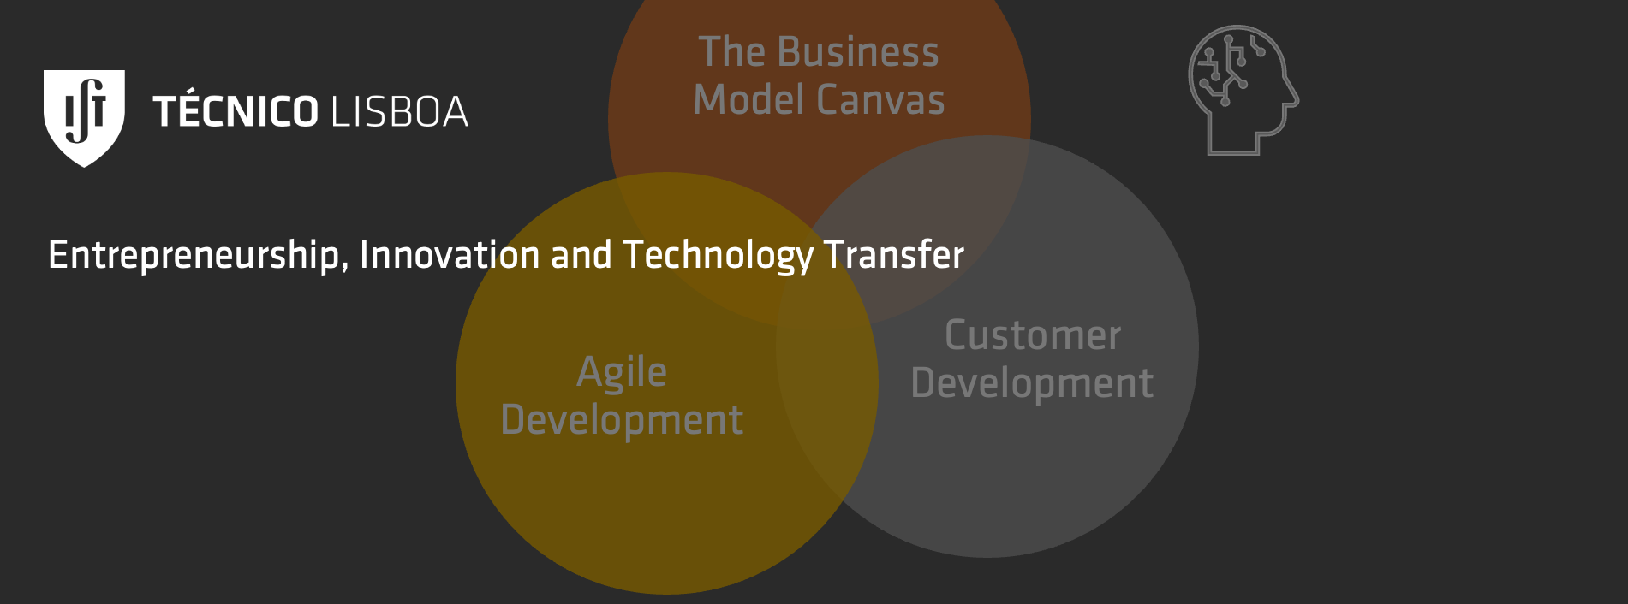

Team Formation: Self-Evaluation

|  |  |  |  |
| --- | --- | --- | --- |
| **Name** | Francisco Tavares | | |
| **Contributions**  (Select 6 or less) | Courageous  Dynamic  Imaginative  Perfectionist  Single-minded  Explorer | Strategist  Cooperative  Goal-setter  Practical  Dedicated  Organizer | Creative  Efficient  Communicative  Diplomatic  Enthusiastic  Troubleshooter |
| **Roles**  (Select 3 or less) | Idea Generator  Problem-Finder  Balloon-Popper | Communicator  Problem-Solver  Puppy-Shooter | Peace Maker  Executor  ___________ |